TSTA Agenda
August 5, 2022 10am CST Zoom Meeting 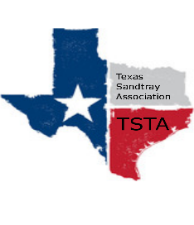
Executive Team & Officers in Attendance
_x_ Salina Loriaux, President _x_ Michelle Beyer, Secretary
_x_ Sheri Shulenberger, President-Elect _x_ Melissa Fleming, Public Relations
_x_ Amanda Robinson, Executive Assistant _x_ Karen Burke, Founding Advisor

- Financial update
  - $7147
- Website update
  - 406 visitors, down 5%
  - 13 new visitors, up 30%
- Conference
  - 39 registrants
  - Duties assigned
- Anything else……………………..
- General updates and next meeting Sept 2nd at 11am

