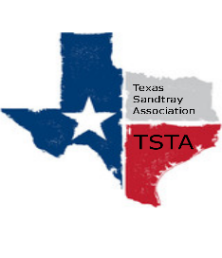
June 15, 2020 10:00 am Zoom Meeting
s

TSTA Minutes

Executive Team & Officers in Attendance
_x_ Karen Burke, President _x_ Sheri Shulenberger, Secretary
_x_ Raquel Sadler, President-Elect _x_ Missy Whitsett, Public Relations
__ Lacey Fisher, Executive Director

- Welcome to our team! Introduction of new team members. Yay!
- Overview of TSTA Karen Burke presented overview power point. Bullet points: Networking & support; Common understanding of expectations through certification; Forward thinking.
- Amanda starting: Amanda Robinson will be added to A+ Federal Credit Union and Lacey Fisher will be taken off as soon as we can meet at the bank. Amanda will be taking over the Executive Director position July 1, 2020.
- TSTA financial report Balance $4,603.26
- “reply all” in board conversations for efficiency Noted!
- TSTA statement No discussion/previously approved and sent out.
- Business cards to be distributed to officers at some point.
- ASTA merger with TSTA 2014 it all began with ASTA; ASTA now shut down and transferred to TSTA (which was formed in 2017) to allow better use of resources. When Amanda comes on board she can help team look for overlaps and moving forward.
- Think about… future virtual training/conference type event? No 2020 in person TSTA conference; all officers encouraged to consider possibilities of virtual training ideas.
- Other updates/focus items as we continue to grow, look for people who might want to continue in leadership positions.
- Schedule next meeting going to wait to set up; touching base once a month via Zoom.

