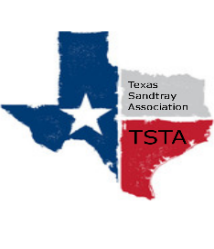
October 3, 2020 10:00 am Zoom Meeting
s

TSTA Minutes

Executive Team & Officers in Attendance
x Karen Burke, President x Sheri Shulenberger, Secretary
__ Raquel Sadler, President-Elect x Missy Whitsett, Public Relations
x Amanda Robinson, Executive Director
- Financial update: $6,627.08
- Website update: website visitors 106; down 62%
- Debrief about Salina training: Learned more about zoom; practiced with speaker but couldn’t see the gap with participants; webinars could be used-pass control over to speaker/someone else; next time could have a meeting; feedback has been good.
- Items brought up in Trainer Meeting with Sheri & Karen: Meetings serve as networking check-in; the leadership goal is to listen and hear; take away question, “What is the hurry?”; modality is face to face. Brainstorm options for people who need sand tray training immediately.
- Looking ahead to 2021, plans for TSTA: 1) Discussed leadership positions/possible website manager. 2) Need training for future. Brainstorm idea: counselors in schools need potential sandtray training. Amanda to reach out to a possibility.
- General updates: 2 new trainers in September; updating homepage on website; discussion regarding receipts vs. documentation: decision receipts are enough; Missy going to post regarding new trainers to social media.
Next Zoom meeting scheduled for Saturday, November 14, 2020 @ 10am.

