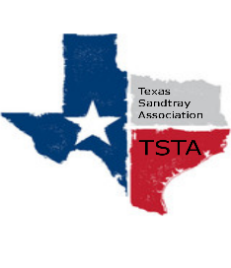
January 27, 2023 10:00 am CST Zoom Meeting
s

TSTA Minutes

Executive Team & Officers in Attendance
x Sheri Shulenberger, President x Nancy Franklin, Secretary
x Tamara Fields, President-Elect x Taylor Vest, Public Relations
x Salina Loriaux, Past-President __ Amanda Robinson, Executive Assistant
x Karen Burke, Founding Advisor

- Training guidelines & requirements- The board reviewed the TSTA training guidelines and requirements. Best practices were discussed as well as ways to create training standards for all trainers.
- Complaints process-Discussion tabled.
- Defining “Training Community” & how to care for it-Discussion tabled.
Next meeting scheduled for Monday, February 6, 2023 @ 10am CST via Zoom.

