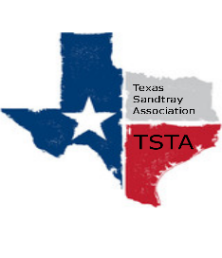
August 10, 2020 10:00 am Zoom Meeting
s

TSTA Minutes

Executive Team & Officers in Attendance
_x_ Karen Burke, President _x_ Sheri Shulenberger, Secretary
_x_ Raquel Sadler, President-Elect __ Missy Whitsett, Public Relations
_x_ Amanda Robinson, Executive Director

- Financial update: Balance $6,182.50
Starting to think about recertification: Think on how to do this; Need verbiage before sending email; Requirement changes; pay same recertification.
- Advanced Trainers per Karen, no one is an advanced trainer. Need to go back to original requirements; change in January to have advanced Train the Trainer.
- # of website hits each month In the last 30 days, TSTA website had 245 hits up 155% of those 161 were unique visits up 130%.
- Call for proposals Salina Loriaux is going to do a 2 hour training on Sept 12th.
Amanda to follow up to see how many have signed up to date. Also, send out call for proposal flyer for additional trainings. Amanda started spread sheet of members that renewed this round. We want to keep offering things that people will want so there is incentive to continue as a member. One incentive is a discount off trainings.
Raquel suggested offering school counselor training. We do offer school based certification levels 1-4. Ideas: we could help school counselors connect to kids at home; how to connect using our sand tray items online. Discussion about Raquel and Amanda facilitating a future training. Another thought was to reach out to a college to offer training.
- Question about certification application Discussion about doing something different with the form regarding how consults submit information.
- Any other updates or items regarding professional goals discussion from last meeting: Karen to set up a one on one with each board member. Discussion about membership: what is process regarding if a member does not pay; how many notices should they receive; when to drop name from the website.

