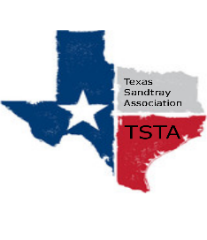
February 6, 2023 10:00 am CST Zoom Meeting
s

TSTA Minutes

Executive Team & Officers in Attendance
x Sheri Shulenberger, President x Nancy Franklin, Secretary
x Tamara Fields, President-Elect x Taylor Vest, Public Relations
x Salina Loriaux, Past-President __ Amanda Robinson, Executive Assistant
x Karen Burke, Founding Advisor

- Training guidelines & requirements- Training guidelines are updated and will become effective immediately.
- General updates and next meeting TBD

