TSTA Agenda
Dec 8, 2022 10am CST Zoom Meeting 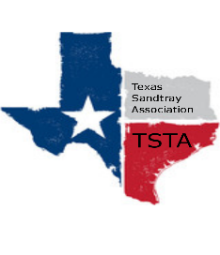
Executive Team & Officers in Attendance
_x_ Salina Loriaux, President _x_ Michelle Beyer, Secretary
_x_ Sheri Shulenberger, President-Elect _x_ Melissa Fleming, Public Relations
__ Amanda Robinson, Executive Assistant _x_ Karen Burke, Founding Advisor

- Financial update - $2,953.87
  - 46 active members
  - How many CCST’s?
- Website update - 204 hits, down 15%, 1 new hit, down 83%
- Election Results/Issues
  - President Elect - Tamara Fields
  - Secretary - Nancy Franklin
  - Public Relations - Taylor Vest
- Anything else……………………..
  - Adding Venmo to account - voted and passed
  - Brainstorming expanding TSTA to national/international levels
- General updates and next meeting Jan 13th at 10am

