TSTA Agenda
August 5, 2022 10am CST Zoom Meeting 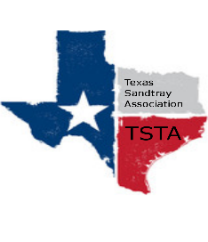
Executive Team & Officers in Attendance
__ Salina Loriaux, President __ Michelle Beyer, Secretary
__ Sheri Shulenberger, President-Elect __ Melissa Fleming, Public Relations
__ Amanda Robinson, Executive Assistant __ Karen Burke, Founding Advisor

- Financial update - $4443.02
- Website update - 445 visits, up 61%; 15 new up 114%
- CCST-T Requirements
  - Require CCST before train the trainer course
  - Advanced certification - Clarify website language
  - Clarify rules for all certifications at meeting after conference
- Review Appeal - put to vote - passed
- Venmo Options
  - After conference - need secondary options for payment
- Conference
  - Budget
    - paid deposit for $800 for venue
    - still owe $400, due week before conference
  - Raffle Drawing
    - drawing at conference
  - Social Media
  - Conference Roles for board
    - Speaker/Tech support - Melissa
    - Speaker Introductions - Salina?
    - Catering - Michelle
    - Miniature set up - Everyone?
    - Welcome and sign in - Amanda
    - CEU - Amanda
    - Raffle
- Anything else……………………..
- General updates and next meeting aug 19

